Mrs. Needham’s
Weekly Newsletter
Week of: September 12,2016

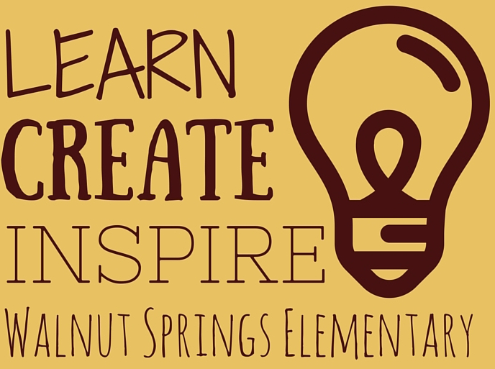

First Grade Parent Orientation: Tuesday, September 20, 2016 in the CL&I (library) 6:00-7:00

Language Arts: I will continue giving the DRA reading assessment. This assessment helps me find the reading level of each student. We are learning strategies that will make us be better readers. We are also learning about nouns and verbs.

Math: We will complete Topic 1, which is about addition strategies and begin Topic 2 on subtraction. You should have noticed a math work page coming home with your student every day. We work on this page in class and usually don’t finish it. You can complete this page with your child if you would like for homework. It does not need to be returned to school. I will usually not be assigning any other math homework.

Science: We are learning about being good scientists and the weather!

Social Studies: We are learning about the 7 Habits of Healthy Kids. This is part of our Leader In Me program.

Spelling words and sight words for this week will be found on the left side of the new Tiger Track that will come home on Monday!

Please have your child bring a healthy snack and a water bottle every day. We eat snack at about 9:30 daily. Lunch is at 11:10.

